**TEAM NAME: PHOENIX**

**PROJECT NAME: TRANQUIL**

**TEAM MEMBERS:**

* SRINIVAS R
* SRIRAM S
* PAYAL MANKOTIA
* ROSHINI S
* SARAVANA KUMAR B

**TEAM LEADER:** SRINIVAS R

**EMAIL ID:** [srinivas.ramachandran99@gmail.com](mailto:srinivas.ramachandran99@gmail.com)

**SOLUTION OVERVIEW**

COVID-19 Pandemic has hit the world massively. In this situation, when there is chaos and disorder everywhere and a humongous threat to mankind, we all are under a great deal of stress, anxiety and fear. TRANQUIL, our chat-bot is here to be your companion during the times of distress and relieve you of the negativity and pressure and to stay calm and composed during this difficult situation. It is built on the fundamental motive of dealing with human emotions, and as we all would agree, to be there for each other in hard and unforeseen circumstances so that we do not let this disease affect our mind. This is a really unexpected pandemic for which we were not prepared and we need a lot of support both for our physical as well as mental well-being in order to stay healthy.

So, TRANQUIL is there for you to keep your away from stress and depression, during this critical period of time.

**SOLUTION DESCRIPTION**

We all know that COVID-19 has taken a toll on mankind, and has left us shaken in a Pandemic of a scale, never seen before, in this modern Science-era. This disease started and continued to spread like wild-fire, in an uncontrollable rate, and the whole world was brought to a stand-still. Every human on this planet has been affected by this pandemic, either directly by getting infected, or indirectly in other means. Due to the rapid spread of the disease, lockdowns were imposed across the globe in all the countries, sooner or later, and due to these lockdowns, we have been seeing people getting affected in new and totally unexpected ways. Students, from all age-groups have been forced to stay indoors, and their education has been put into risk. People who work for a periodic salary have been fired from their jobs due to insufficient funds, Business owners have incurred huge losses, and Shops from small-scale household manufacturers, to Industrial giants have all been forced to shut down and suffer huge amounts of losses. The most affected are the frontline heroes who work day and night, every day of the week, putting their lives at stake, to protect the common man. These heroes are none other than our Health Care Workers – Doctors, Nurses, Lab Technicians, Pathologists, Pharmacists etc. and the Police and Armed Forces. They have been staying close to those who have been infected to treat them even though they too have families waiting for them, like ours. They have been sacrificing their comfort of staying indoors and are staying outside so that we can stay peaceful and healthy indoors. Also due to all the above factors, there has been an alarming increase in the rate of depression and anxiety among people, and also, an increased suicide rate.

In this time of crisis, we undergo huge waves of emotions, and all the surrounding factors can take a toll on our mental health and well-being. In order to prevent that, here is our chat-bot, TRANQUIL, to assist you, be your solace and maintain your emotional balance. It is a chat-bot built using Watson Assist service in the IBM Cloud Platform. It is a powerfully trained chat-bot, which recognises the emotions of the user and provides help accordingly. It is trained with a high accuracy anticipating the mental state of people in the current situation, so that it is of great help and assistance to the people.

**SOLUTION ARCHITECTURE:**

**Algorithm**:

**Step 1: START**

**Step 2:**

* To converse with TRANQUIL, a user has to login to Facebook, and greet TRANQUIL in chat box.
* TRANQUIL responds to the user and ask about the user’s profession.
  + The User enters their profession –
  + Student
  + Employee
  + Health Care Worker
  + Home Maker
  + Business Owner
* User is a STUDENT
  + TRANQUIL interacts with student to understand their state of mind.
  + Based on the student’s reply the conversation proceeds to understand their intent better.
  + If the student is feeling low, TRANQUIL will try to talk and find the reason behind it.
    - For example, if the student is missing friends, TRANQUIL will suggest him to call his friends or if not possible then talk to parents and share his/her feelings with them.
    - Suppose the student is not satisfied, then TRANQUIL will talk further to make the student feel better.
  + If the student is feeling good, TRANQUIL will converse to know more about student’s day etc.
* User is an EMPLOYEE
* TRANQUIL starts conversing with the employee to know about his/her feelings.
* If the employee is stressed, TRANQUIL will interact with the employee the understand the root cause of stress.
* For example, if the employee is stressed due to pay cuts, TRANQUIL will empathize with the employee and try to make him/her feel better.
* If the employee is happy, TRANQUIL will encourage him/her to stay positive.
* User is a HEALTH CARE WORKER
* TRANQUIL interacts with the Health Care Worker to know their frame of mind.
* Based on the Health Care Worker’s reply the conversation proceeds to evaluate their intent better.
* If the Health Worker is scared because of Corona Virus pandemic, TRANQUIL will provide moral support.
* If the Health Care Worker is in depression, TRANQUIL will provide helpline numbers and refer to counselors.
* User is a HOME MAKER
* TRANQUIL chats with the Home Maker to understand their thoughts and feelings. Depending upon the Home Maker’s reply the conversation proceeds to understand their thoughts and situation better.
* If the Home Maker is not feeling good and stressed, TRANQUIL will ask for the cause of stress.
  + For example, if the Home Maker is stressed because she is worried about her family members who are on frontline fighting against Covid – 19. TRANQUIL will tell her to take care of her family and take all precautionary measure and stay strong.
* If the Home Maker is feeling happy, TRANQUIL will suggest her good ideas to stay positive and use time effectively during crisis.
* User is a BUSINESS OWNER
* TRANQUIL interacts with the Business Owner to understand their feelings. Based on the Business Owner’s reply the conversation proceeds to understand their intent better.
* If the Business Owner is worried, TRANQUIL will interact with them to understand their main cause of stress.
  + For example, if the Business Owner is worried due to the loss in Business and delayed payments of clients. TRANQUIL suggests links of strategies to improve their business and minimize losses.
* TRANQUIL replies “Try rephrasing” for any other ambiguous response.

**Step 3: STOP**

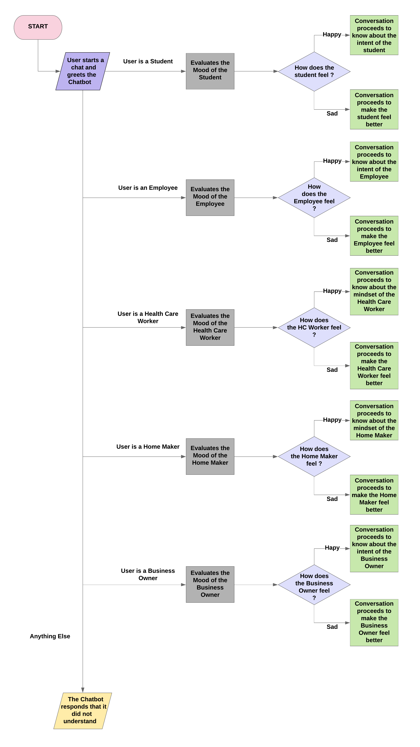

**FLOWCHART**

**IBM CLOUD SERVICES USED**

**IBM WATSON ASSISTANT**

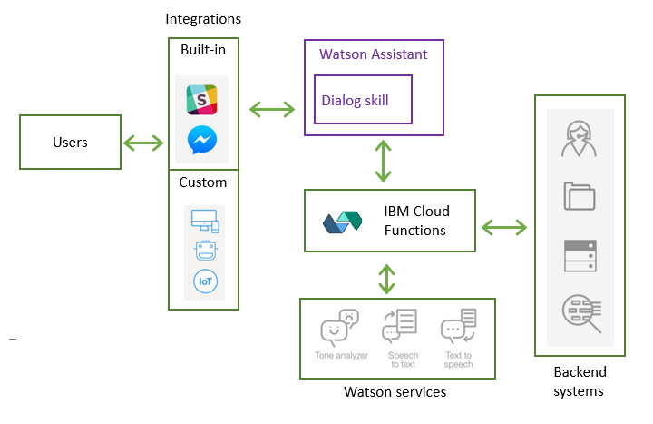

Watson Assistant is a conversation AI platform that helps you provide customers fast, straightforward and accurate answers to their questions, across any application, device or channel. By addressing common customer inquiries, Watson Assistant reduces the cost of customer interactions, helping your agents focus on complex use cases – not repetitive responses.

Most chat-bots try to mimic human interactions, frustrating customers when a misunderstanding arises. Watson Assistant is more than a chat-bot. It knows when to search for an answer from a knowledge base, when to ask for clarity and when to direct users to a human. And since it can be deployed in any cloud environment.

Building a chat interface takes months, creating a meaningful experience takes longer.

Our web chat, embedded with best practices, can be deployed in minutes. Also, builds seamless agent escalation, customizable styling, and critical security features. It provides a simple and intuitive interface for building responses to user questions no developer experience required.

Chat-bot projects that use Watson Assistant involve three phases: scope, design, and integrate.

In the scope phase, you gather requirements for the conversation and how customers support the use case. Create an empathy map, and build a system context diagram. Then, you extract the potential list of intents. Intents are the purposes or goals that are expressed in a user's input, such as answering a question. After you define intents, you assess the sentences that lead to those intents.

In the design phase, you create an instance of Watson Assistant and use its builder tool to define the intents and the entities. An entity represents a class of object or data type that is relevant to a user's purpose. At the end of the design phase, you start the dialog flow and unit-test it.

Finally, in the integrate phase, you develop the web app or micro service that interacts with Watson Assistant. You implement the logic to handle the conversation context, and add other components to complement the requirements.

